WEB APPLICATIONS AND AI

**Table of Contents**

Part A: Trip Agency Management System 3

System Architecture and Design Patterns 3

Database Design and Entity Relationship 6

Technology Implementation and Integration 7

User Interface and User Experience Design 9

Administrative Functionality and Content Management 13

Security Implementation and Session Management 16

Development Process Reflection and Technology Evaluation 17

Conclusion 18

Part B 18

Dataset Overview 18

Methodology 19

Model Development Results 20

Linear Regression Equation 21

Model Performance Metrics 21

Revenue Prediction Analysis 21

Next Year's Revenue Forecasting 21

10% Advertising Cost Increase Revenue Estimation 22

Business Implications 22

Return on Investment Analysis 22

Strategic Recommendations 23

Conclusion 23

References 24

# Part A: Trip Agency Management System

## System Architecture and Design Patterns

The application architecture is based on the Model-View-Controller (MVC) design pattern, so the separation is observed, and the solution is maintained (Moorthy *et al*., 2022). The architecture of the system is constructed of three different layers that include the presentation layer executed by using JSP pages, the business logic layer executed by Java Servlet, and the data access layer executed by the Data Access Objects (DAO) pattern of implementation.

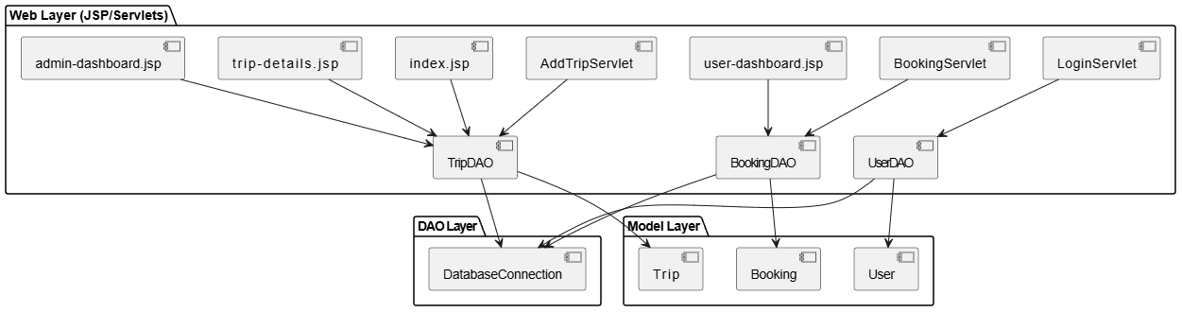

**Figure 1: Architecture of the System**

(Source: Self-Created)

The use of the DAO pattern was calculated to separate database operations and offer an uncluttered interface between abstraction of the business logic and data persistence tier.

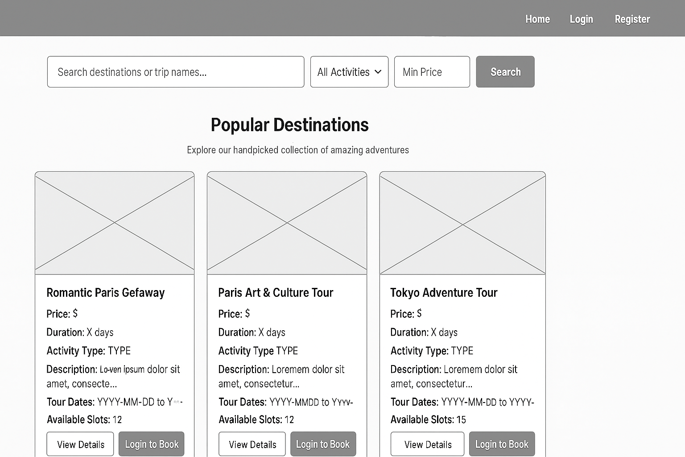

**Figure 2: Home Page Wireframe**

(Source: Self-Created)

This is the best way since the code will be re-usable and the whole system will be more acceptable to future changes of the database.

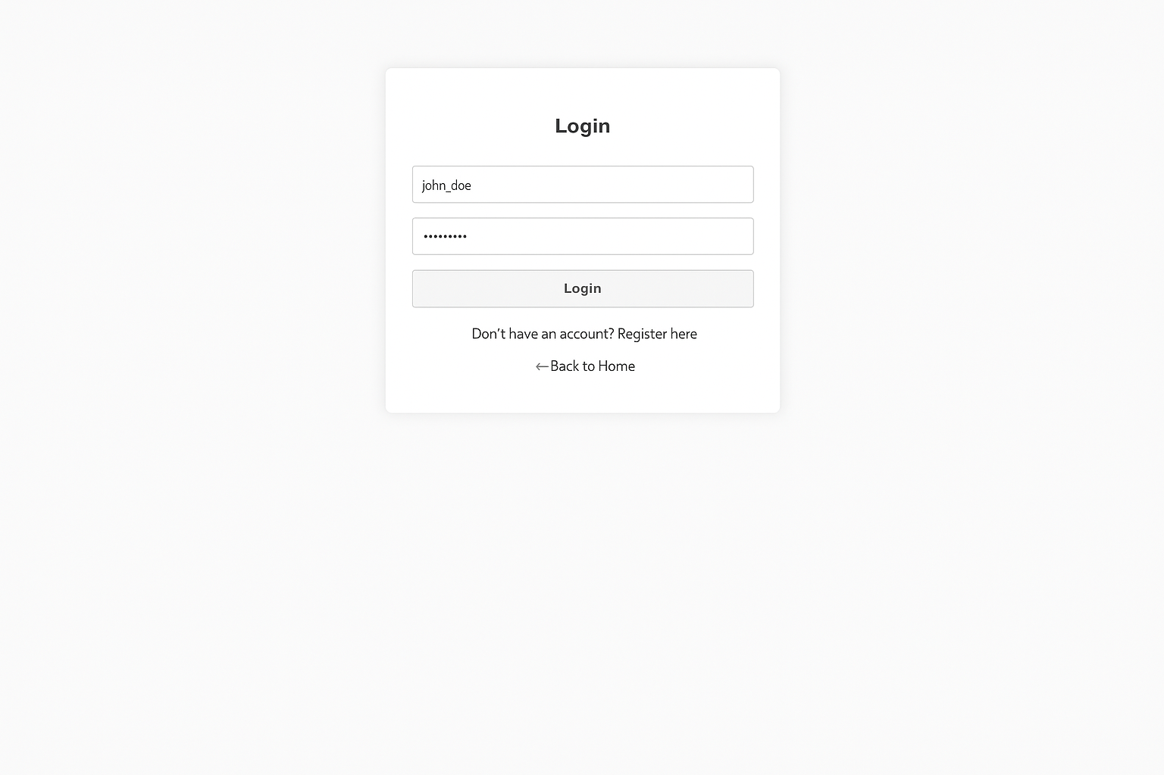

**Figure 3: Login Page Wireframe**

(Source: Self-Created)

Only certain DAO classes are used in the system such as user-management operation using UserDAO, trip-related database operations using TripDAO, and booking-related transactions using BookingDAO.

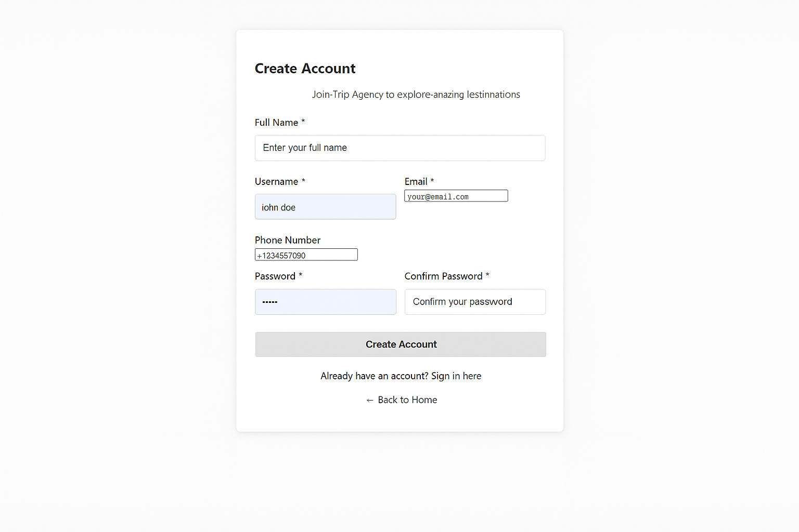

**Figure 4: Signup Page Wireframe**

(Source: Self-Created)

To achieve this, the databaseConnection utility class is carried out using the Singleton pattern that will help in managing the resources efficiently and allows there to be one entry point of connecting to the database within the application.

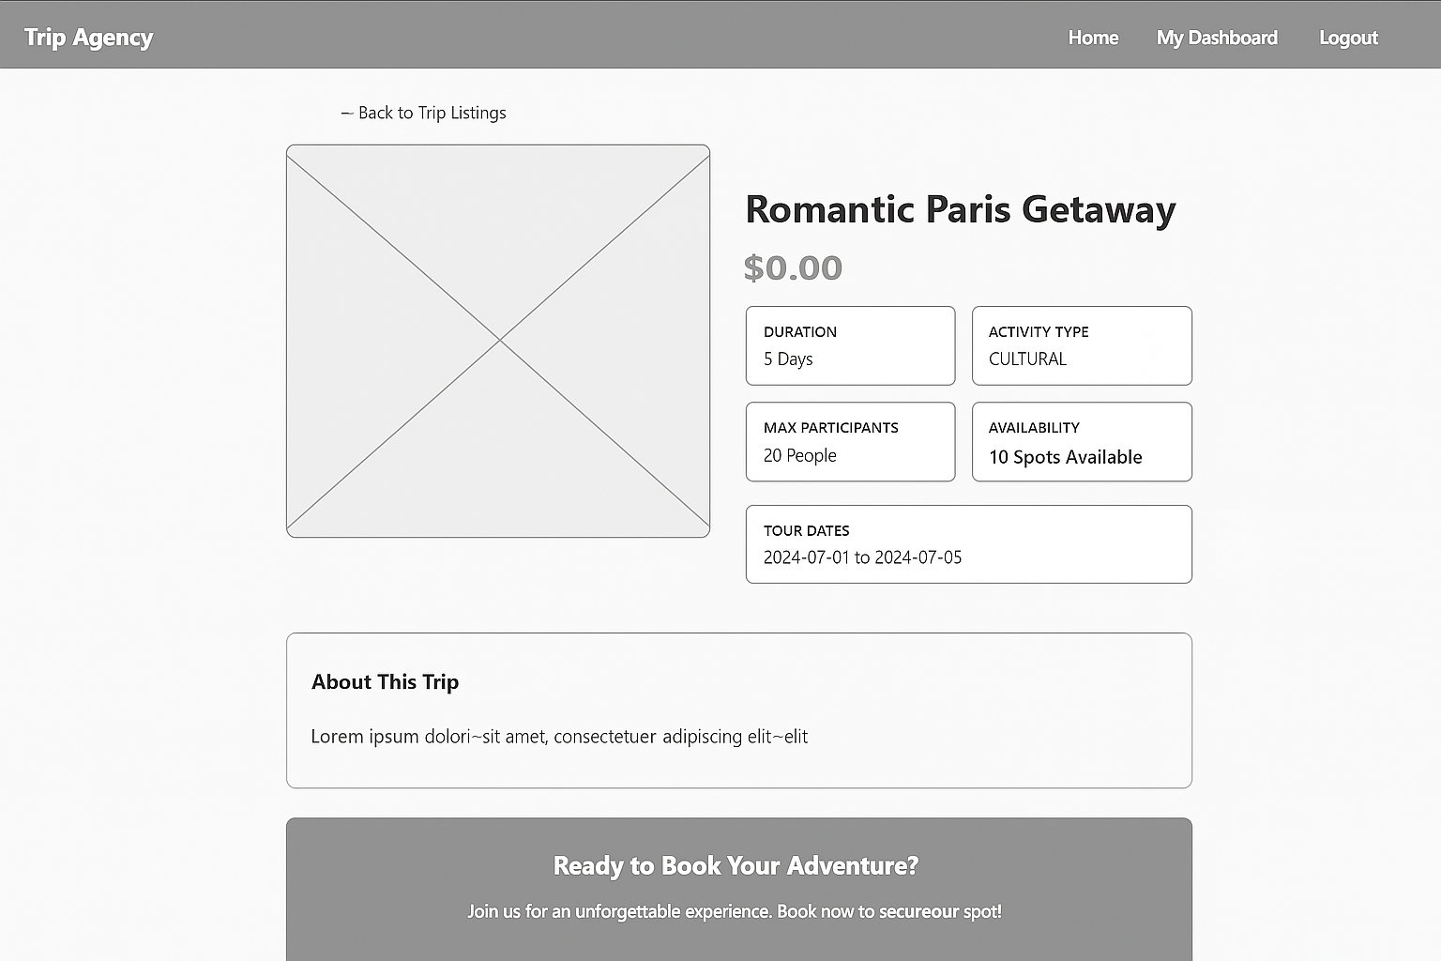

**Figure 5: Trip Details Page Wireframe**

(Source: Self-Created)

This design option eliminates the possibility of resource failure and optimizes performance of a system in terms of efficient control of database links.

## Database Design and Entity Relationship

The database design was made with the idea of following the normalization principles so that there would be no redundancy of data in the database. The entity relationship model has three main entities, viz, User, Trip and Booking, which have a clear relationship and enable functional requirements of the system.

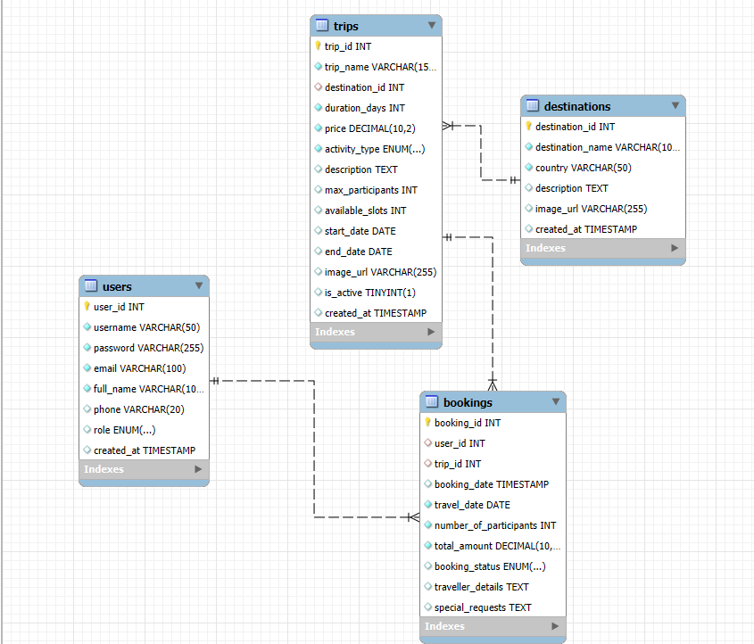

**Figure 6: Database Design**

(Source: Developed Using SQL)

The user entity provides the user authentication credentials and the profile information of the user and it supports both general users and administration users using the role-based access control. Trip entity has the full details relating to trips such as destination, price structure, duration specification and classifications of activities. Booking object is the entity that forms the transactional record that ties the users with the chosen trips they have, involving the booking period, the number of participants, and the tracking of the status.

## Technology Implementation and Integration

The system uses the Java Enterprise Edition platform to provide powerful web application functionality. Java Servlets are the main controllers and operate on HTTP requests and responses, and perform business logic operations (Rahkovsky *et al*., 2021). Multiple functions are offered by the servlet architecture, such as user authentication with the help of LoginServlet, trip management via the centralized servlets of the system, and a booking processing class in separate booking handlers.

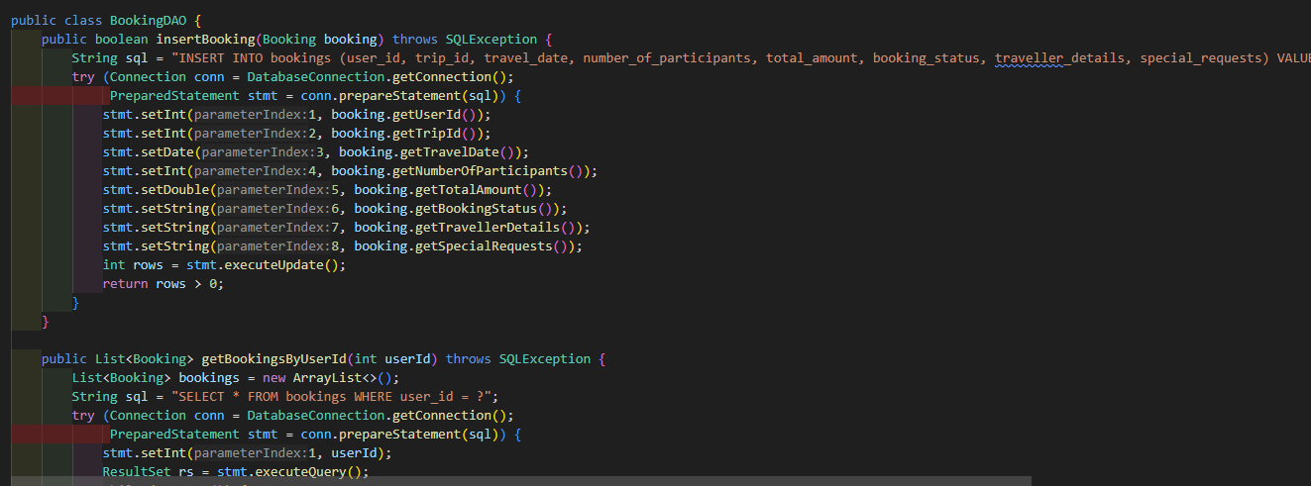

**Figure 7: Accessing data using Data Access Objects**

(Source: Developed Using SQL)

JavaServer Pages technology offers the functionalities of dynamic generation of content and serves as the means of developing responsive user interfaces that dynamically adjust to user interactions and data states. The JSTL features are added in the implementation of JSP to improve reading of the code and decrease the scripts, which is beneficial in terms of a better separation of the presentation logic and business logic. Connection with databases was accomplished through Java Database Connectivity (JDBC) API, which offers standard database access and does not matter what kind of database management system is being used.

## User Interface and User Experience Design

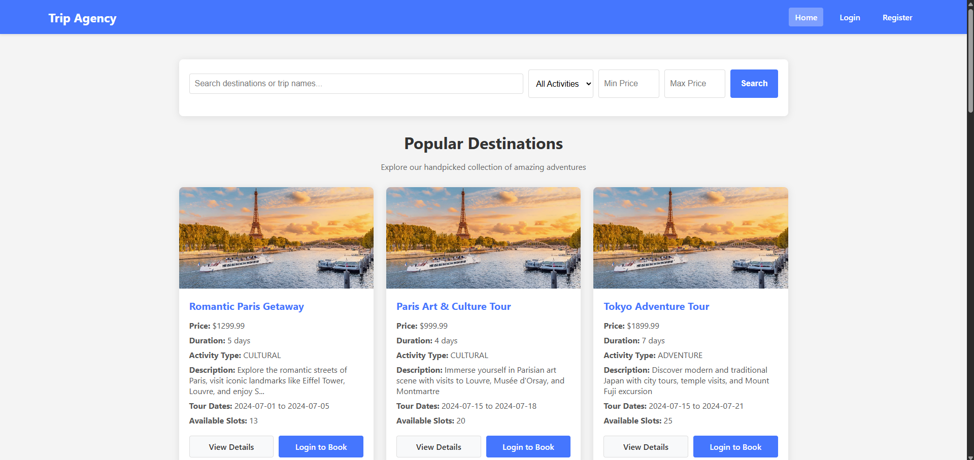

**Figure 8: Home Page of the system**

(Source: Developed Using JSP)

It has a priority on user interface design in terms of usability and accessibility where the responsive design principles apply to make it suitable to use in a wide range of devices and screens. The interface adheres to a rational navigation pattern and helps a customer consult the route finding and booking process in a user-friendly manner.

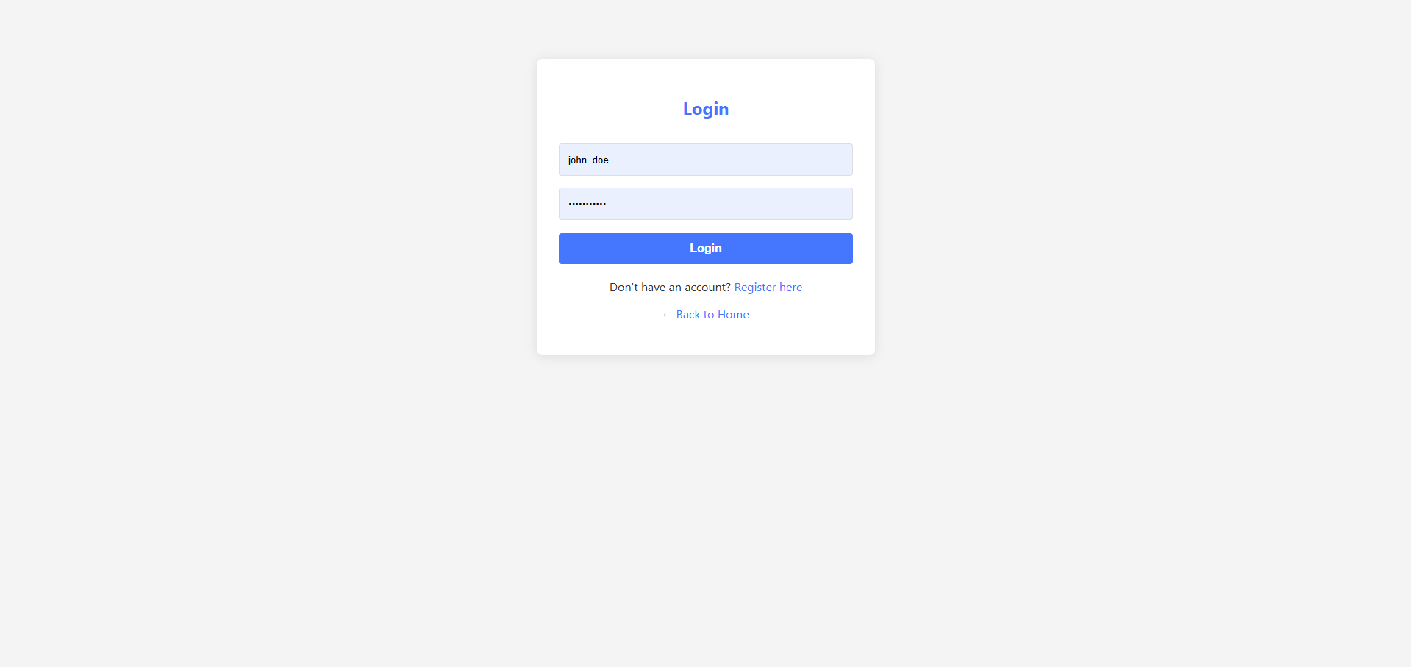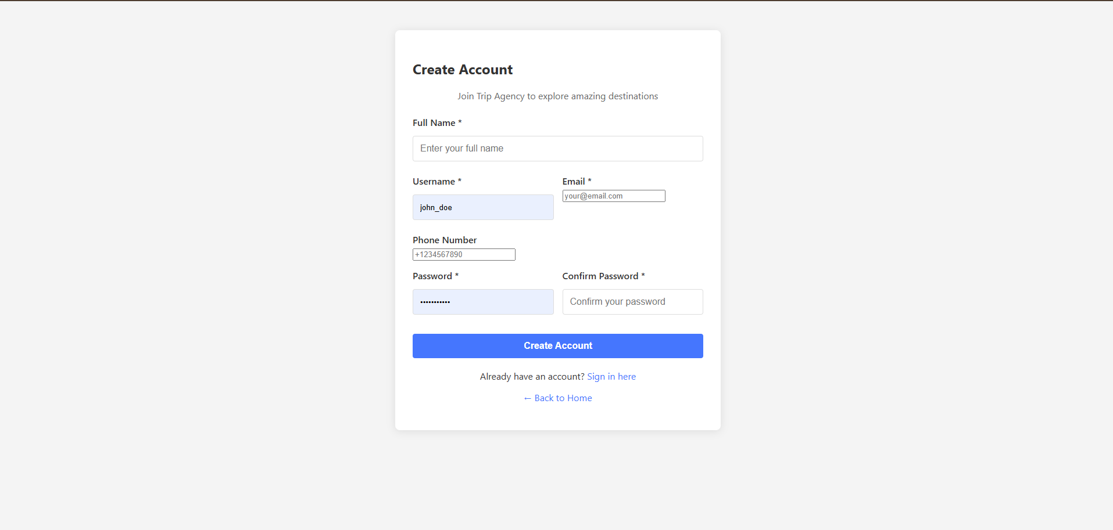

**Figure 9: Login and Logout Pages of the Application**

(Source: Developed Using JSP)

The home page gives a well-regulated overview of the trips offered with an option of searching by destination, duration, the price range, and type of activity. The multi-criteria search capability allows the users to effectively find trips that suit their choice and needs.

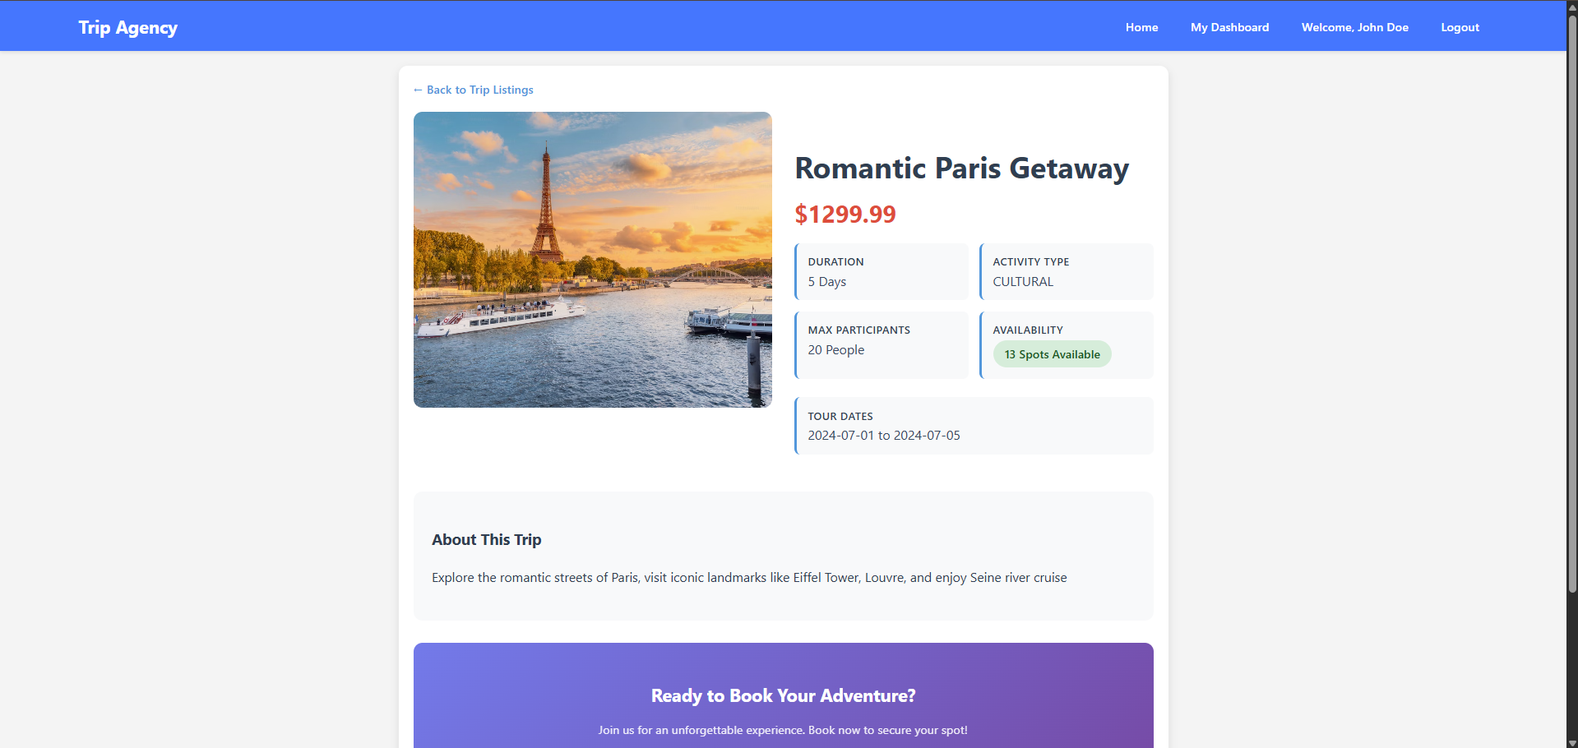

**Figure 10: Trip Details Page**

(Source: Developed Using JSP)

The pages about the trip give all the necessary information in details such as itineraries, price breakdown, and availability thereby helping one make an informed choice.

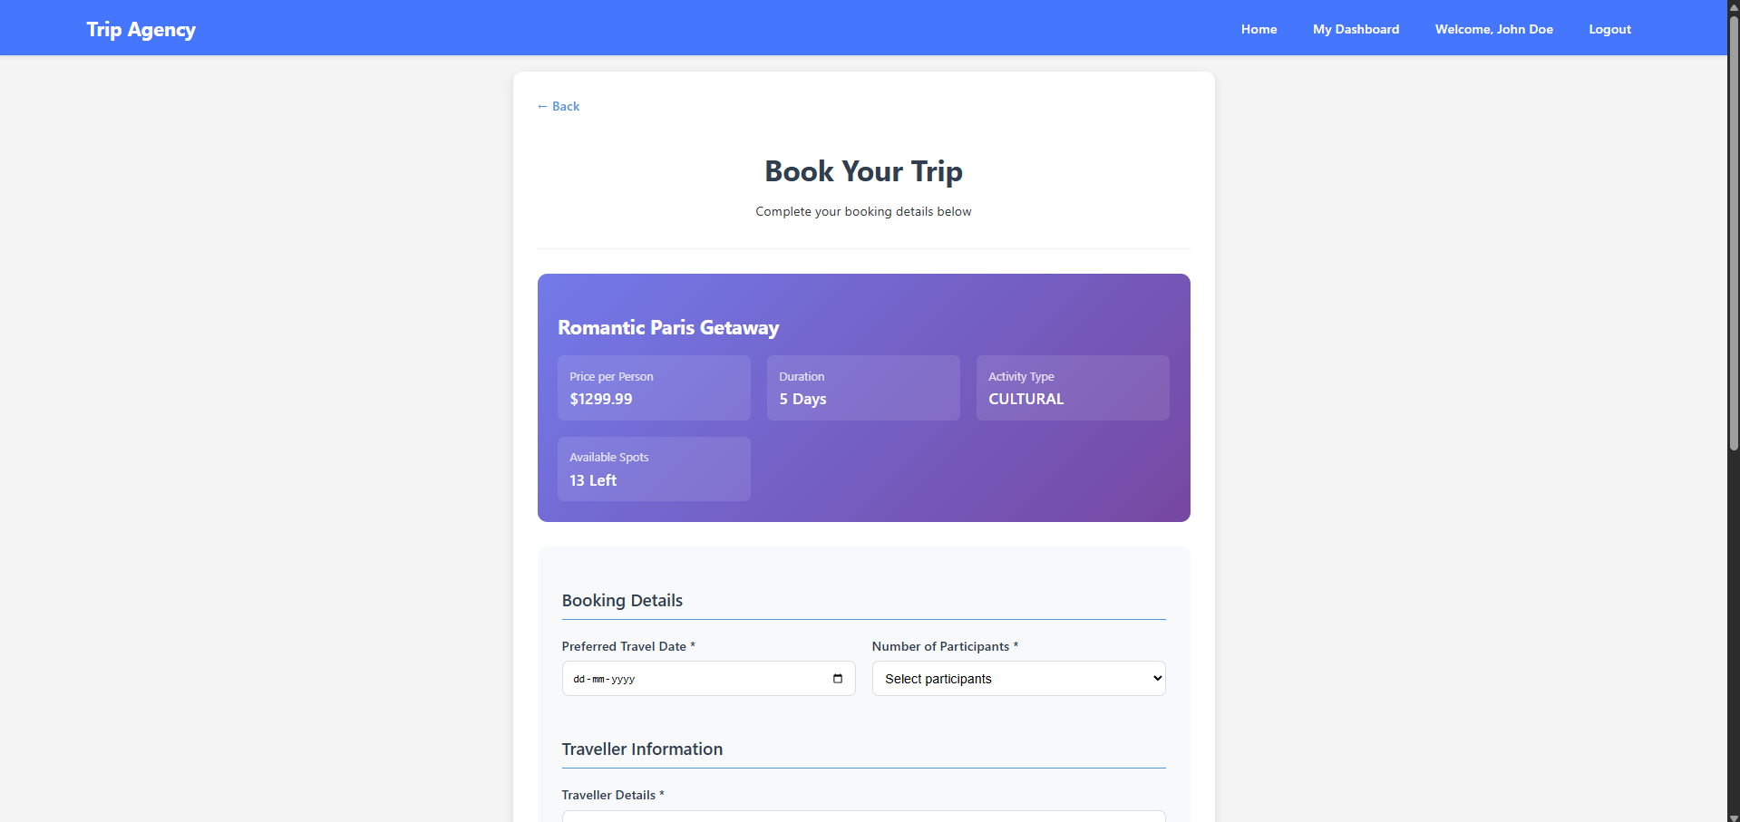

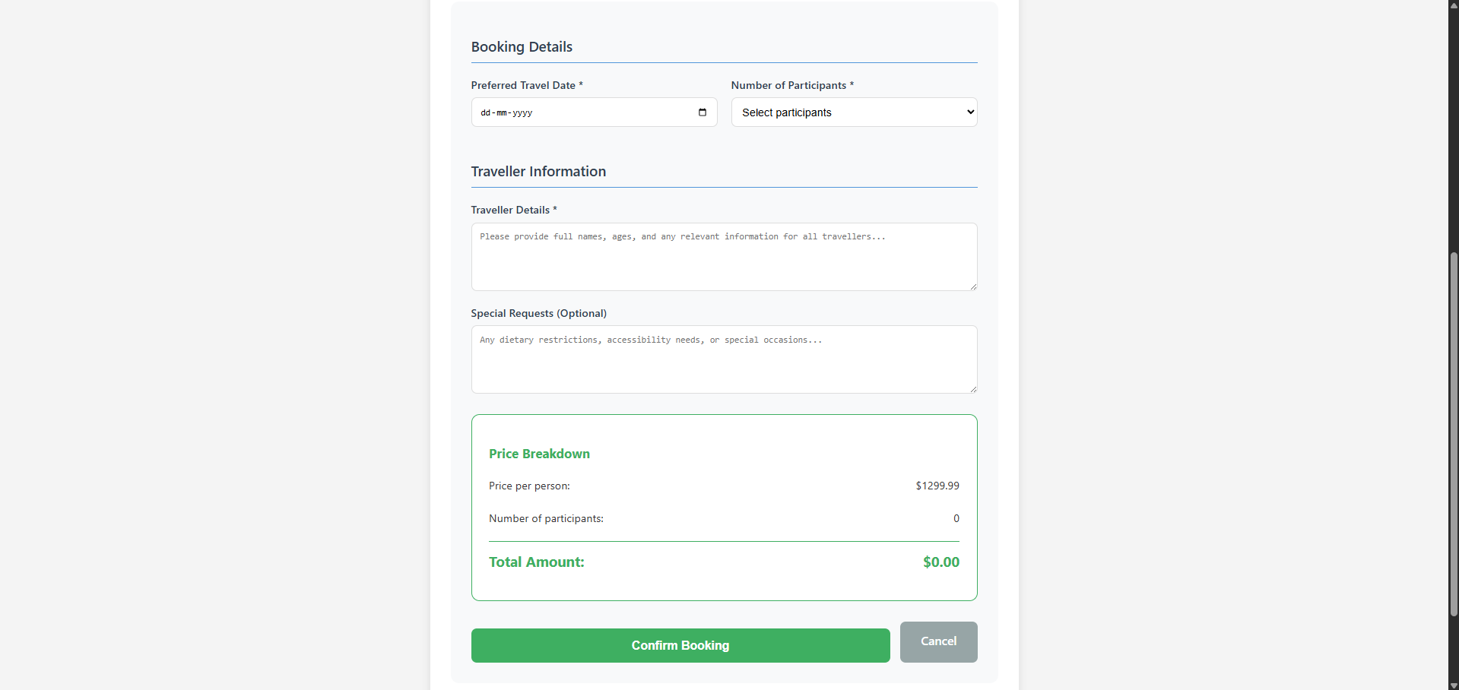

**Figure 11: Trip Booking Page**

(Source: Developed Using JSP)

The interface of the booking will be functioning through the mechanisms of form validation and user feedback to prevent misuse and direct users and lead to making a reservation.

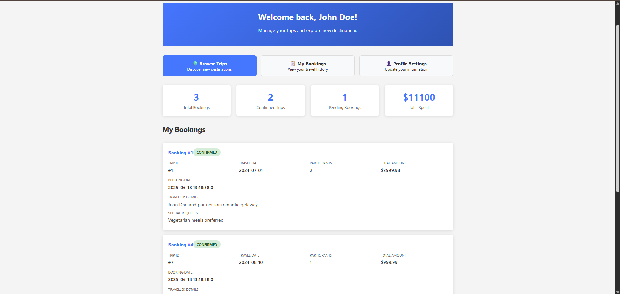

**Figure 12: User Booking Management Dashboard**

(Source: Developed Using JSP)

The system gives an instant response to the booking requests and keeps a user dashboard that the customer can follow their booking and reservation history.

## Administrative Functionality and Content Management

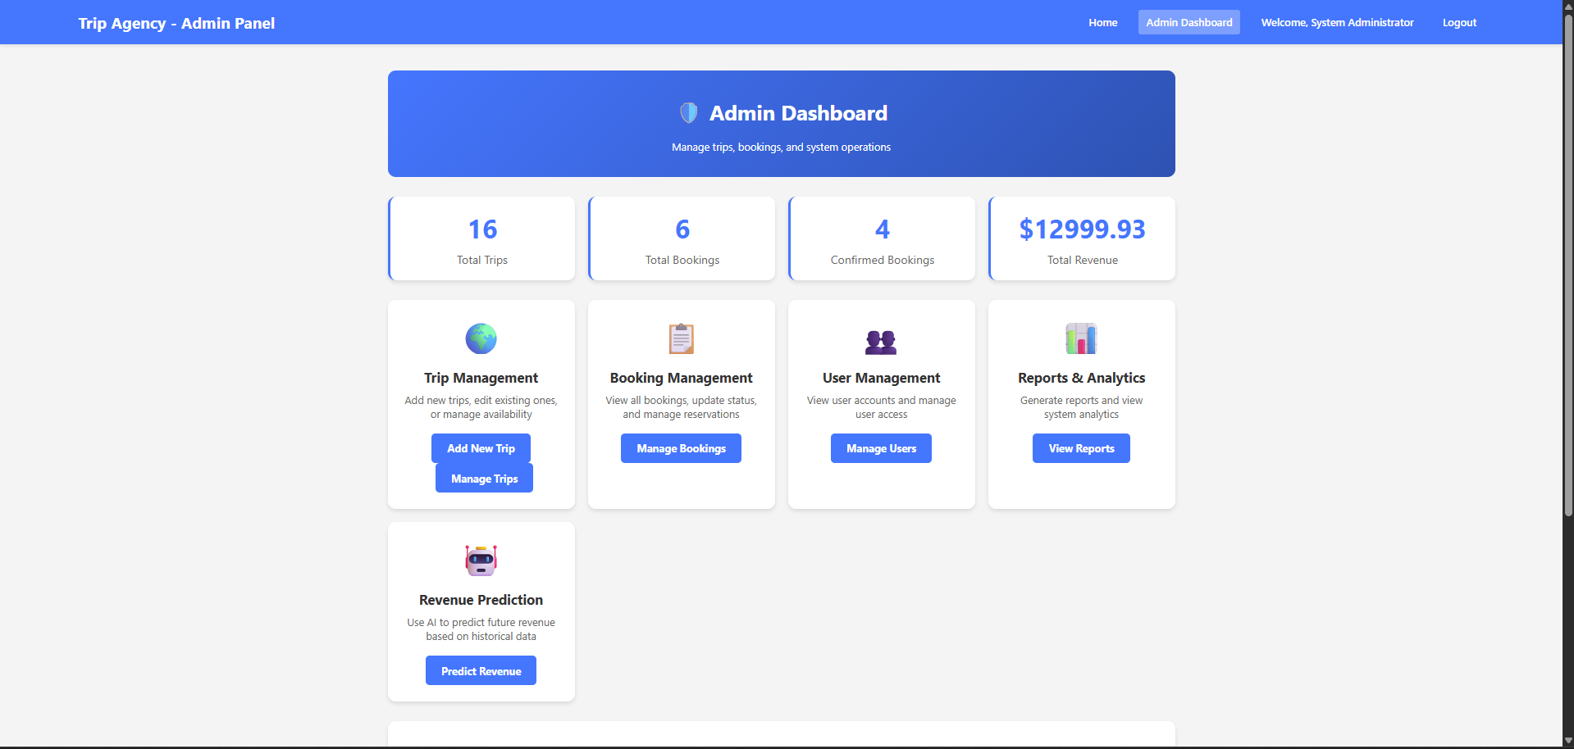

**Figure 13: Admin Dashboard**

(Source: Developed Using JSP)

The interface to the administration offers full systems to train an inventory of trips and to administer the operations of the business. Individual management panels allow the administrative users to create, modify, and delete the trips with data consistency and referential integrity.

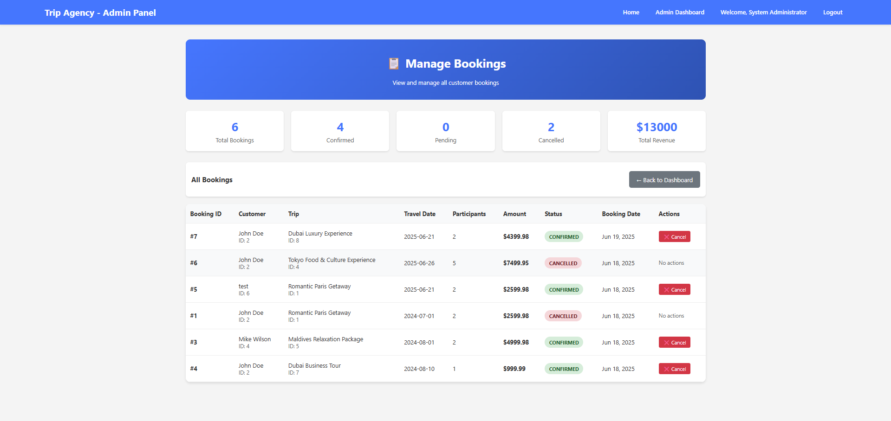

**Figure 14: Manage Bookings**

(Source: Developed Using JSP)

Its trip management system can enable the administrators to create new offerings of the trips in full detail of features such as the destinations, types of activities, definite prices and availability of packages (Samsonov *et al*., 2021).

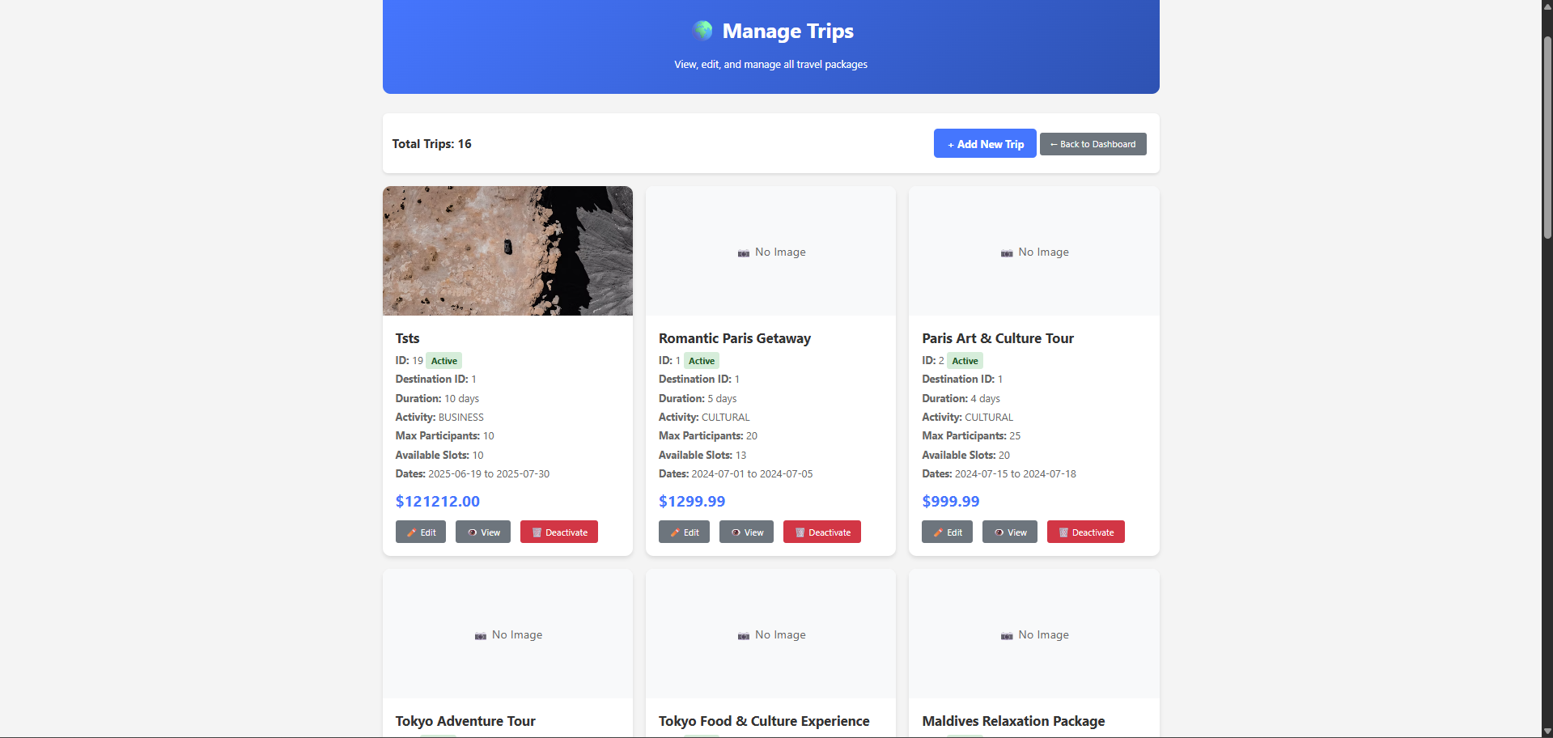

**Figure 15: Manage Trips**

(Source: Developed Using JSP)

The system facilitates dynamic price strategy and seasonal pricing adjustments and gives flexibility to revenue management.

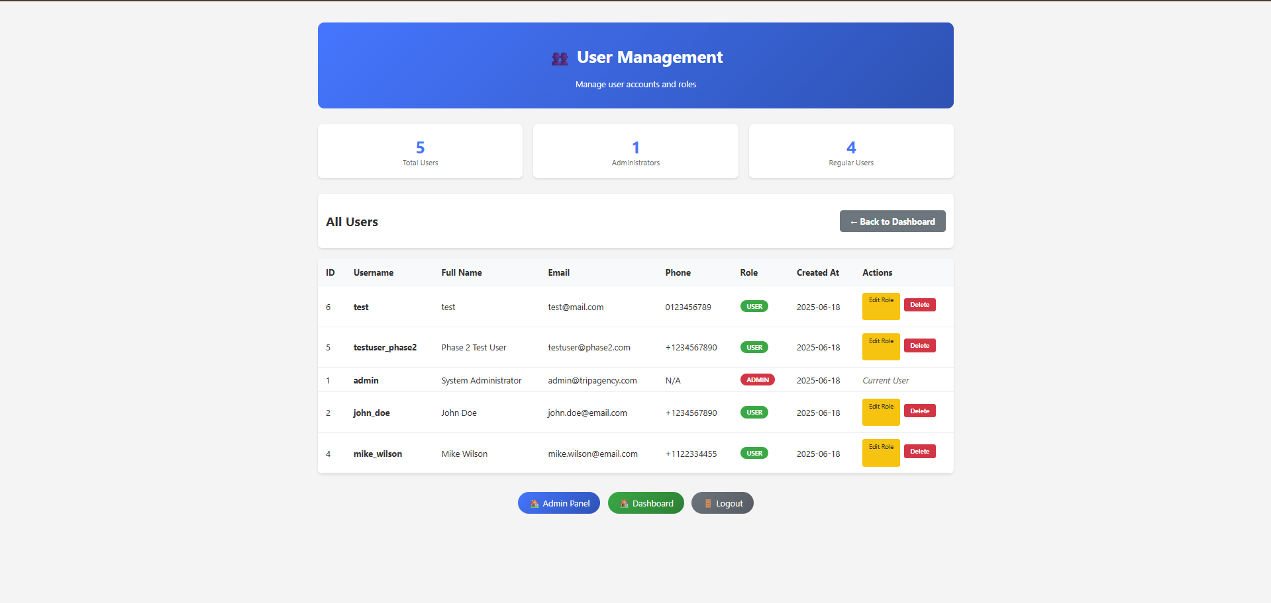

**Figure 16: Manage Users**

(Source: Developed Using JSP)

The ability to handle bookings enables the administrator to look at the reservation trend and revise the booking status, and create and print operational reports.

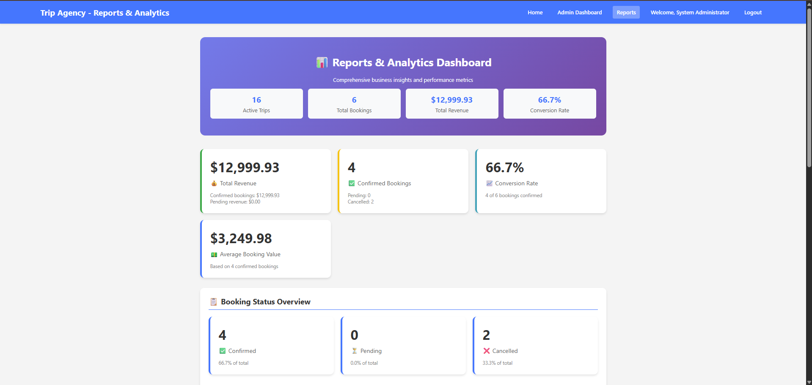

**Figure 17: Reports and Analytics Dashboard**

(Source: Developed Using JSP)

Administrative actions are tracked through audit trails, and this promotes accountability and compliance with business processes.

## Security Implementation and Session Management

The system was designed with security considerations in mind, and it provided mechanisms of user authentication that secured sensitive user information and administrative facilities (Samsonov *et al*., 2021). The system uses session-based authentication that has proper timeout policies to determine a balance between the security needs and the convenience of the users.

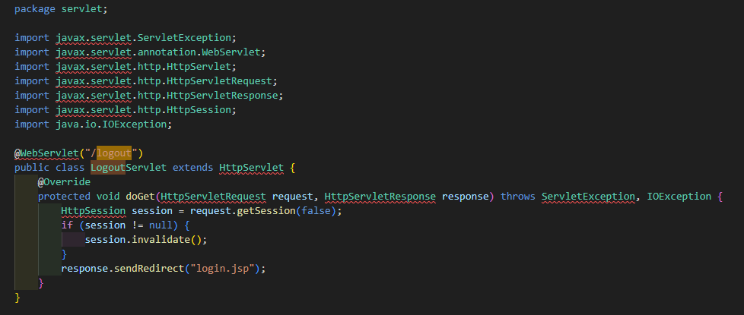

**Figure 18: Session Management Implementation Evidence**

(Source: Developed Using JSP)

Access control by role guarantees that administrative tasks are limited in access to authorized users and proper access level is given to categories of users. Password manipulation also includes standard security measures in the industry and database queries include parameterized statements as a protection against SQL injections.

## Development Process Reflection and Technology Evaluation

The process that was involved in development was iterative, and it followed a well-defined set of phases in which implementation of features and testing was achieved. Such an approach allowed detecting technical difficulties early enough and iteratively testing and improving the functionality of the systems.

The choice of technologies in JEE was also beneficial in this project scope since they are well established and have great documentation support (Rahkovsky *et al*., 2021). The use of the technologies Servlets and JSP provided enough flexibility to support simple content presentation as well as complex business logic-oriented operations. These technologies will be long-term maintainable and accessible to the developers due to their standardization.

The JDBC enabled the integration of databases to offer decent data persistence features with database vendor independence. The strategy promotes future expansion needs and also enables a possible migration towards enterprise-type database solutions in case of developing business requirements.

## Conclusion

The Trip Agency Management System is effective in providing the needed functionality, and the given work is achieved with a proper use of JEE technologies and with references to the known principles of software engineering. The system is basically a strong framework on which travel agencies will operate, and yet it still has the scalability feature which can be exploited in the future. The flexibility of modular architecture, as well as standardized implementation of technology, guarantees the possibility to modify the system according to the changing business needs and the innovation in the sphere of the travel industry.

# Part B: Sales Prediction Using Weka

## Dataset Overview

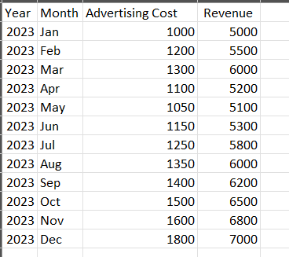

**Figure 19: Dataset**

(Source: Excel)

A total of 12 monthly data on the performance of an advertising agency were used, having three major variables: one variable i.e. Year as temporal variable showing year in which the data was recorded, the second variable i.e. Advertising Cost as monthly advertising spending carried out by the agency and the third variable i.e. Revenue as monthly revenue made by the agency.

In the data preprocessing stage, filtering operations with Weka AllFilter and Remove functions were performed, and the obtained data were refined with a view to identifying the main relationship between the advertising costs and revenue outcomes. Preprocessing involved the removal of the Month attribute because it was intended to simplify the analysis and emphasize the main predictive relationship.

## Methodology

The analysis was performed using the LinearRegression classifier of Weka integrated into a Java Server Pages (JSP) application with two regression model parameters. Regularization factor 1.0E-8 and attribute selection method 0, which represents no attribute selection settings, and 4 decimals to ensure accuracy of output. The JSP implementation gave the user a web-based way to interact with the Weka machine learning library directly, such that data processing and model execution ran smoothly.

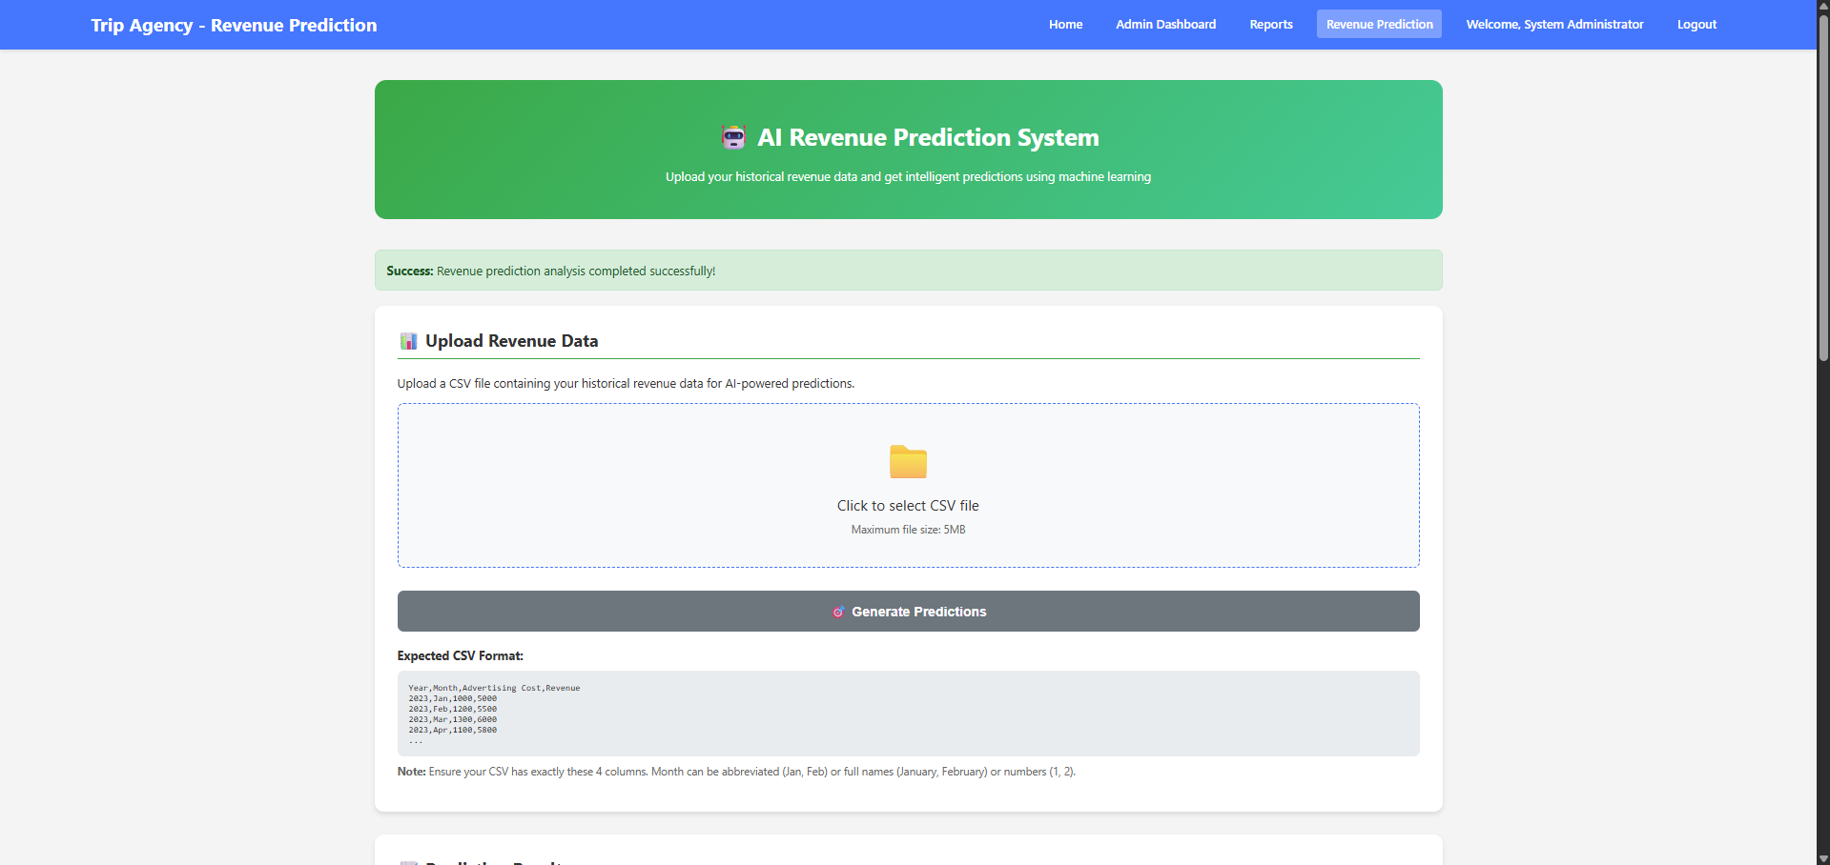

**Figure 20: Sales OPrediction Interface**

(Source: Weka and JSP)

A ten-fold cross-validation strategy was used in order to have a robust model evaluation and to reduce the chances of overfitting. This approach does not overestimate performance since the data is divided into ten subsets, which are used to train and test the data, respectively, ten times each.

## Model Development Results

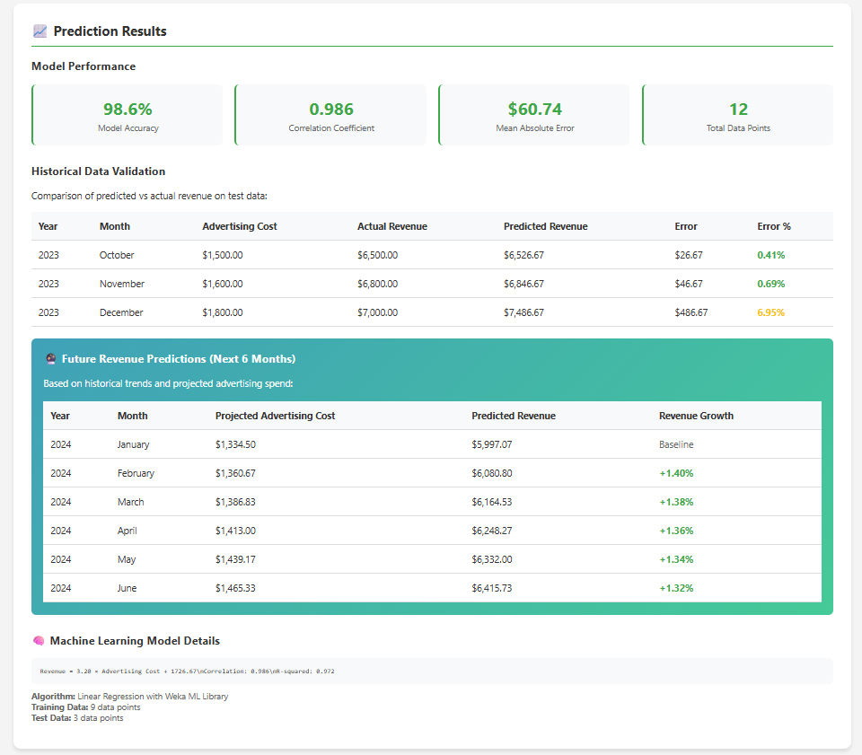

**Figure 21: Sales Prediction Results**

(Source: Weka and JSP)

### Linear Regression Equation

The developed linear regression model generated the predictive equation as follows:

**Revenue = 2.7833 (cost advertising) + 2225.1682**

This equation points out some very important aspects, such as the coefficient 2.7833 shows that with an increase in the advertising cost by a unit the revenue will increase by about 2.78 units, the coefficient 2225.1682 shows the amount of revenue generated when the advertising cost is zero and the fact that this coefficient is positive shows that there is an anticipated positive relationship between advertising investment and revenue generation.

### Model Performance Metrics

The results of the cross-validation show an unbelievable model performance as correlation coefficient shows a very strong positive linear relationship between advertising expenditure and revenue, as the value of the correlation coefficient is 0.9675, and 93.6 percent of the variance in revenue is explained by advertising spending (Ratra *et al*., 2021). The error analysis discloses a Mean Absolute Error, Root Mean Squared Error, Relative Absolute Error, and Root Relative Squared Error of 130.9887, 167.6058, 20.9227 %, and 22.9667 %, respectively.

This is because of the low error rates, especially the relative errors, which make the model very accurate and reliable in predictions.

## Revenue Prediction Analysis

### Next Year's Revenue Forecasting

The proposed advertising costs were used to perform predictions in terms of revenue in the coming year using the established model of linear regression. This model equation will act as the basis of these projections: Revenue = 2.7833 *Advertising Cost + 2225.1682. Since the value of the correlation coefficient is high i.e. 0.9675, and the model accurately predicts the data, as there is no fluctuation in the market conditions and stability of the business environment.

In order to illustrate the predictive ability of the model, it was possible to derive baseline projections of revenue based on the history of patterns in regard to advertising costs (Damodharan *et al*., 2022). The linear correlation that is determined by the implementation of the Weka-JSP can be used to easily calculate future revenues using the projected advertising spending in the next year.

### 10% Advertising Cost Increase Revenue Estimation

A complete analysis was prepared to determine the revenue impact in case the advertising cost is increased by 10 percent in the coming year. The linear regression model was used to calculate the revenue, assuming the current baseline advertising expense of the following year as C, and in case of a raise of the expense by 10 per cent., this will be determined as 1.1C.

The calculations of revenue show that: Original projected revenue = 2.7833 x C + 2225.1682, and new projected revenue with advertisement increased = 2.7833 (1.1C) + 2225.1682. This would be an extra revenue resulting in the 10 percent cost increment, and it would be 2.7833(1.1C-C) = 2.7833(0.1C) = 0.27833C.

In this analysis, it can be noted that an increment of 10 percent in the costs of advertising in the coming year results in additional revenue of around 27.8 percent of the value of the advertising costs (Moorthy *et al*., 2022). On a practical standpoint, in case the projected advertisement budget next year is 10,000 and we can increase the corresponding budget by 10 per cent to 11,000, the additional revenue created would be 2,783, which makes the total estimated increase in revenue to be 30,058 to 32,841.

## Business Implications

### Return on Investment Analysis

This model coefficient shows that it requires a dollar to gain about 2.78 dollars of revenue, which is a 178 percent return on investment. Such a huge ROI qualifies the extra spending in terms of advertising and justifies aggressive marketing.

### Strategic Recommendations

In regard to the result of the analysis, some strategic recommendations can be listed, among which is the investment scaling, as the strong positive correlation allows scaling the advertising investments, especially due to the favorable ROI ratio (Amaro *et al*., 2022). Budget optimization as the increase in costs by 10 percent scenario shows, the predictable growth in revenues, allowing confident budgetary estimation, and the performance monitoring, because the model can be used as the baseline on which the performance monitoring, based upon the analysis of deviations, can be performed.

## Conclusion

The linear regression was able to form an effective predictive model in the estimation of revenues relative to the cost of advertising. The high correlation coefficient of the model, 0.9675, and the insignificant levels of errors exhibit great certainty that the model is robust in predictions. According to the analysis, a 10 percent increase in the advertising expenditure will also increase the revenues proportionately, which justifies decision-making in data-driven marketing activities.

The model developed has been of great assistance in strategic planning, allocation of budget as well as evaluating performance, giving the agency the positive influence of utilizing the money on adverts in the most efficient ways to generate revenue. This will keep the validation and updating of the model with recent data on a regular basis, so that the relevance and accuracy to the business of making decisions by the company is maintained.

# References

Amaro, D., Rosenkranz, M., Fitzpatrick, N., Hirano, K. and Fiorentini, M., 2022. A case study of variational quantum algorithms for a job shop scheduling problem. *EPJ Quantum Technology*, *9*(1), p.5.

Damodharan, S., Reddy, S.V. and Sarojamma, B., 2022. WEKA models for rainfall data. *Int J Emerg Technol Innovat Res*, *9*, pp.C111-C119.

Dou, Y. and Meng, W., 2023. Comparative analysis of weka-based classification algorithms on medical diagnosis datasets. *Technology and Health Care*, *31*(1_suppl), pp.397-408.

Merlini, D. and Rossini, M., 2021. Text categorization with WEKA: A survey. *Machine Learning with Applications*, *4*, p.100033.

Moorthy, P.V.R., Sarojamma, B. and Reddy, S.V., 2022, August. Development of machine learning models using WEKA for atmospheric data. In *Journal of Physics: Conference Series* (Vol. 2312, No. 1, p. 012080). IOP Publishing.

Rahkovsky, I., Toney, A., Boyack, K.W., Klavans, R. and Murdick, D.A., 2021. AI research funding portfolios and extreme growth. *Frontiers in Research Metrics and Analytics*, *6*, p.630124.

Ratra, R., Gulia, P. and Gill, N.S., 2021, July. Performance Analysis of Classification Techniques in Data Mining using WEKA. In *Proceedings of the International Conference on Innovative Computing & Communication (ICICC)*.

Samsonov, V., Kemmerling, M., Paegert, M., Lütticke, D., Sauermann, F., Gützlaff, A., Schuh, G. and Meisen, T., 2021, February. Manufacturing Control in Job Shop Environments with Reinforcement Learning. In *ICAART (2)* (pp. 589-597).

Zeng, Y., Liao, Z., Dai, Y., Wang, R., Li, X. and Yuan, B., 2022. Hybrid intelligence for dynamic job-shop scheduling with deep reinforcement learning and attention mechanism. *arXiv preprint arXiv:2201.00548*.